CHAPTER 1
INTRODUCTION
1.1PROBLEM DEFINITION:
Agriculture is the main occupation of the majority of population in every district. The farmers of the district rely heavily on agriculture for earning their livelihood. The development of agriculture depends on various aspects such as type of soil, relief, vegetation, climatic conditions, use of irrigation, HYV seeds, fertilizer, pesticides and insecticides, use of mechanical tools and implements, as well as proper scientific rotation of crops by which production be enhanced. The agriculture is mainly based on weather conditions. Due to variations in weather i.e, if weather condition is good then the production of yield may increase as well as when weather condition is not good then the production of yield decreases. For better production of yield we can analyse previous weather conditions and estimate approx production of yield, we can predict if any issues arises. By the project we analyse previous weather conditions and represent in a graph format so that we can easily understand in which weather production is good and we can decide which crop gives better production of yield. By this we can increase the production of yield which leads to get better income of our district

  - EXISTING SYSTEM:
Generally, agricultural department stores the information about the different factors that leads to crop yield. It mainly focuses on production increment and productivity of agricultural crops using environment friendly science and technology while ensuring increased net farm income to the farmers through various schemes, programmes and welfare measures. However, does not investigate the root cause for the decrease in crop yield/agriculture risk. They store the information manually. This information is not used for future analysis. So, further prediction from previous data is required

  - PROPOSED SYSTEM:
Our project processes the data collected from records of agriculture departments which are stored manually through data visualization tools like weka/tableau/R tool. The result will be presented in a graphical format for easy understanding of user. By using this result the agricultural department will make a decision for future crop production. This will minimizing risk/ increasing the crop production.

2.2.1. ADVANTAGES OF PROPOSED SYSTEM:
The proposed system results in the following advantages:
- Identifying yield according to the rainfall conditions.
- Accurate results for the future crop production.
- High production of crop yield.

1.4 SOFTWARE REQUIREMENTS SPECIFICATION:
Software Requirements:
Operating system : Windows95/98/2000/XP/10
Application Software : R tool
Dataset : Crop Details dataset, Weather Details dataset, Soil details dataset

Hardware Requirements:
Processor - Pentium-III
Speed - 1.1 GHz
RAM - 256 MB (min)
Hard Disk - 20 GB
Floppy Drive - 1.44 MB

1.5 SYSTEM REQUIREMENT SPECIFICATION
FUNCTIONAL AND NON-FUNCTIONAL REQUIREMENTS
A System Requirements Specification (SRS) – a requirements specification for a software system – is a complete description of the behavior of a system to be developed. It includes a set of use cases that describe all the interactions the users will have with the software. Use cases are also known as functional requirements. In addition to use cases, the SRS also contains non-functional (or supplementary) requirements. Non – functional requirements are requirements which impose constraints on the design or implementation (such as performance engineering requirements, quality standards, or design constraints).

1.5.1 FUNCTIONAL REQUIREMENTS:
Naive Bayes algorithm
It is a classification technique based on Bayes’ Theorem with an assumption of independence among predictors. In simple terms, a Naive Bayes classifier assumes that the presence of a particular feature in a class is unrelated to the presence of any other feature. For example, a fruit may be considered to be an apple if it is red, round, and about 3 inches in diameter. Even if these features depend on each other or upon the existence of the other features, all of these properties independently contribute to the probability that this fruit is an apple and that is why it is known as ‘Naive’.
Naive Bayes model is easy to build and particularly useful for very large data sets. Along with simplicity, Naive Bayes is known to outperform even highly sophisticated classification methods.
Bayes theorem provides a way of calculating posterior probability P(c|x) from P(c), P(x) and P(x|c). Look at the equation below:
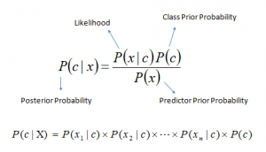Above,
- P(c|x) is the posterior probability of class (c, target) given predictor (x, attributes).
- P(c) is the prior probability of class.
- P(x|c) is the likelihood which is the probability of predictor given class.
- P(x) is the prior probability of predictor

Decision Trees:
The decision tree approach is more powerful for classification problems. Decision tree builds classification or regression models in the form of a tree structure. It breaks down a dataset into smaller and smaller subsets while at the same time an associated decision tree is incrementally developed. The final result is a tree with decision nodes and leaf nodes. A decision node (e.g., Outlook) has two or more branches, Leaf node (e.g., Play) represents a classification or decision. The topmost decision node in a tree which corresponds to the best predictor called root node. Decision trees can handle both categorical and numerical data.
1.5.2 Non-Functional Requirements:
In systems engineering and requirements engineering, a non-functional requirement is a requirement that specifies criteria that can be used to judge the operation of a system, rather than specific behaviors. This should be contrasted with functional requirements that define specific behavior or functions. The plans for implementing non-functional requirements are detailed in the system architecture. The non-functional requirements are “system shall be <requirement>”. Non-functional requirements are often called qualities of a system.
The following are the Non functional requirements for our system:

Availability:
A system's availability, or "uptime," is the amount of time that it is operational and available for use. User can be access system by using executable file or short cut.

Accessibility:
Specifies how well the software utilizes scarce resources: CPU cycles, disk space, memory, bandwidth, etc. Since this is developed as pc client application this will able to access only single user at a time.

Portability:
Portability specifies the ease with which the software can be installed on all necessary platforms, and the platforms on which it is expected to run. By using appropriate server versions released for different platforms our project can be easily operated on any operating system, hence can be said highly portable.

Efficiency:
Specifies about the data classification and predict the suitable results pertaining to the symptoms based on the nutrition values of N-P-K. The software utilization can be effectively used in terms of memory, disk space.

Scalability:
Software that is scalable has the ability to handle a wide variety of system configuration sizes. The nonfunctional requirements should specify the ways in which the system may be expected to scale up (by increasing hardware capacity, adding machines etc.). Our system can be easily expandable. Any additional requirements such as hardware or software which increase the performance of the system can be easily added.

Usability:
For every type of soil nutrients, can apply this algorithm and get the desired results.

Performance:
The performance constraints specify the datasets of the nutrient values. We classify the nutrient values based on plant symptoms. After the classification mainly observe the rice diseases in growth stages.
- Based on the different levels the diseases are identified.
- The normal values and critical values are taken for prediction by using regression function.

CHAPTER 2
SYSTEM ANALYSIS
2.1 FLOW ORIENTED MODELING:

2.1.1 Data Flow Diagram (DFD):
A Data Flow Diagram (DFD) is also known as a Process Model. Process Modeling is an analysis technique used to capture the flow of inputs through a system (or group of processes) to their resulting output. The model is fairly simple in that there are only four types of symbols – process, dataflow, external entity, data store.
Process Modeling is used to visually represent what a system is doing. It is much easier to look at a picture and understand the essence than to read through verbiage describing the activities. System Analyst after talking with various users will create DFD diagrams and then show them to users to verify that their understanding is correct. The process models can be created to represent an existing system as well as a proposed system.
The following are some of the symbols in Process Modeling represents.
- Process
- Data Object
- Data Store
- External entity

Process:
An activity or a function that is performed for some specific reason; can be manual or Computerized; ultimately each process should perform only one activity.

Symbol:

Data Flow:
Single piece of data or logical collection of information like a bill.

Symbol:

Data Store:
Collection of data that is permanently stored.

Symbol:

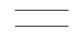
External Entity:

A person, organization, or system that is external to the system but intersects with it.

Symbol:

The following are the levels of Data Flow Diagrams:

Level 0 DFD:
- The level 0 DFD (also known as the context level DFD) is the simplest DFD.
- The outermost level (Level 0) is concerned with how the system interacts with the outside world.
- This level basically represents the input and output of the entire system.

Level 1 DFD:
- The basic modules of the system are represented in this phase and how data moves through different module is shown.
- The level 1 DFD provides a high level view of the system that identifies the major processes and data stores.

Level 2 DFD and other level of DFD:
- Each process from level 1 is exploded even more into processes. This decomposition continues for each level.
- The number of levels possible depends on the complexity of the system.

DFD Principles
- The general principle in Data Flow Diagramming is that a system can be decomposed into subsystems, and subsystems can be decomposed into lower level subsystems, and so on.
- Each subsystem represents a process or activity in which data is processed. At the lowest level, processes can no longer be decomposed.
- Each 'process' (and from now on, by 'process' we mean subsystem and activity) in a DFD has the characteristics of a system.
- Just as a system must have input and output (if it is not dead), so a process must have input and output.
- Data enters the system from the environment; data flows between processes within the system; and data is produced as output from the system.

Salient Features of DFD’S
- The DFD shows flow of data, not of control loops and decision are controlled considerations do not appear on a DFD.
- The DFD does not indicate the time factor involved in any process whether the dataflow take place daily, weekly, monthly or yearly.
- The sequence of events is not brought out on the DFD.

Constructing a DFD:
Several rules of thumb are used in drawing DFD’S:
1. Process should be named and numbered for an easy reference. Each name should be representative of the process.
2. The direction of flow is from top to bottom and from left to right. Data traditionally flow from source to the destination although they may flow back to the source. One way to indicate this is to draw long flow line back to a source. An alternative way is to repeat the source symbol as a destination. Since it is used more than once in the DFD it is marked with a short diagonal.
3. The names of data stores and destinations are written in capital letters. Process and dataflow names have the first letter of each work capitalized.
4. A DFD typically shows the minimum contents of data store. Each data store should contain all the data elements that flow in and out.

Data Flow Diagrams:
Level-0 DFD:
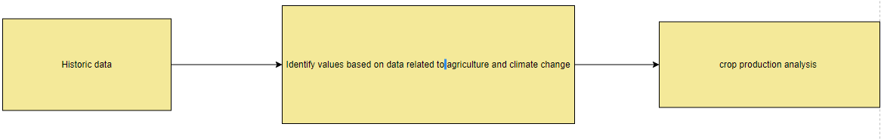
Fig 2.1:

Level-1 DFD:

Fig 2.2:

Level-2 DFD:
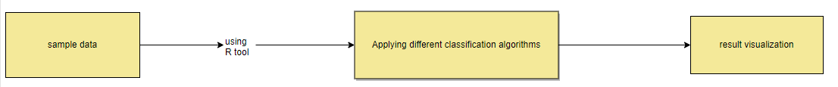

2.1.2 Flow Charts:
A flowchart is a type of diagram that represents an algorithm or process, showing the steps as boxes of various kinds, and their order by connecting them with arrows. This diagrammatic representation illustrates a solution to a given problem. Process operations are represented in these boxes, and arrows; rather, they are implied by the sequencing of operations. Flowcharts are used in analyzing, designing, documenting or managing a process or program in various fields.
A flow chart diagram typically consists of shapes such as ovals, diamonds and boxes that contain words relating to a certain issue and lines with arrows connecting boxes to one another. Flowcharts are used in designing and documenting complex processes or programs. Like other types of diagrams, they help visualize what is going on and thereby help the viewer to understand a process, and perhaps also find flaws, bottlenecks, and other less-obvious features within it. There are many different types of flowcharts, and each type has its own repertoire of boxes and notational conventions. The two most common types of boxes in a flowchart are:
- a processing step, usually called activity, and denoted as a rectangular box
- a decision, usually denoted as a diamond.

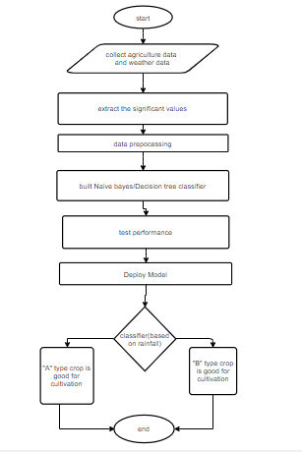

Fig 2.6: Flow Chart Diagram for identifying rice diseases according to the growth stages based on nutritional disorders.

